# TASK 3

1. For this task, search the following malware:
   1. Adware
   2. Spyware
   3. Scareware
   4. Crapware
   5. Roughware
2. For each of the above terms, answer the following questions:
   1. What is it?
   2. How can you get it?
   3. What can it do to your computer?
3. Create a table (consists of all the terms in A) with elements for columns as below and put the information related to it.

|  |  |  |  |  |  |
| --- | --- | --- | --- | --- | --- |
| **No.** | **Malware** | **Focus of attack** | **Threat agent** | **Symptom** | **One real attack case (name, date, and other related info)** |
| 1. | Adware |  |  |  |  |
| 2. | Spyware |  |  |  |  |
| 3. | Scareware |  |  |  |  |
| 4. | Crapware |  |  |  |  |
| 5. | Roughware |  |  |  |  |

# TASK 4

1. Exploit Vulnerability Using Metasploit
   1. Find **THREE (3)** exploits for Windows 7 in a lab virtual machine other than the one used in the lab module.
   2. Run the exploits and record all the steps and screen capture. Explain and give some information about the exploits that you launched.
   3. Report your findings.
2. Web Vulnerability Scanning
   1. Explore Kali Linux applications and tools from 01 until 14 as in the picture below.

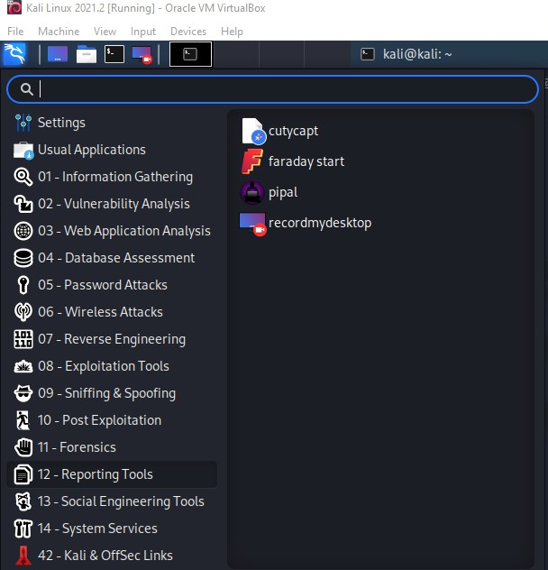

* 1. Run XAMPP Web Server (on Windows machine).

* 1. Find **TWO (2)** suitable tools/scripts to launch vulnerability scanning towards the web server service. You can use Kali Linux or any tools/scripts from outside the Kali Linux machine for this task.
  2. Report your findings on how to use the tools/scripts and what result you get from the vulnerability scanning activity.
  3. Compare the results between the two tools/scripts that you used.

***Provide a step-by-step screen snapshot with the explanation.***

**Marking Guide**

|  |  |  |  |
| --- | --- | --- | --- |
| Item | 0 | In between | Full mark |
| Front page | Not provide |  | Provide all |
| Task 3 | Not provide | Missing task and not complete | Provide all and complete |
| Task 4 | Not provide | Missing task and not complete | Provide all and complete |
| List of references | Not provide |  | Correct and complete |